Comparative Study Sample from Heather’s website:
http://www.thinkib.net/visualarts/page/16885/part-1the-comparative-study

Part 1,The Comparative Study

- Overview
- New Visual Arts Curriculum
- The 3 Course Components
- Part 1,The Comparative Study

Introducing the Comparative Study
The newest addition to the VA curriculum is the CS, an independent critical and contextual investigation that explores artworks, objects and artifacts from differing cultural contexts. The CS is one of the 3 components required by the new curriculum and it constitutes 20% of the final mark. It is basically a comparative, analytic investigation that strikes a balance between visual and written, with NO PRESCRIBED FORMAT
The CS is not an extended essay, it doesn’t even have to be an essay!

What exactly IS required for the CS?
SL 10-15 pages (screens)
HL 10-15 Pages ( screens) + 3-5 Pages (screens) which analyze the extent to which their work has been influenced by the art and artists examined.
The pages submitted examine and compare at least three artworks at least two of which need to be by different artists.
The work selected for comparison should come from contrasting contexts (local, national, international and/or intercultural). Ideally students should see one of the works firsthand.
Acknowledge sources!
The number of pages actually refers to the number of screens because this will be presented and viewed on computer screens; bear this in mind and present accordingly!

The role of the Visual Journal in the CS
The Visual Journal collects and contains all the students visual and written experimentation and investigations.
- Use the Journal to specifically document the CS research and responses to each piece.
- Include detailed interpretations, evaluations, and comparisons.
- Select and adapt from these pages for the CS
The CS can be used to enhance your understanding of art and help to give context to your own work (HL)

Making meaningful connections
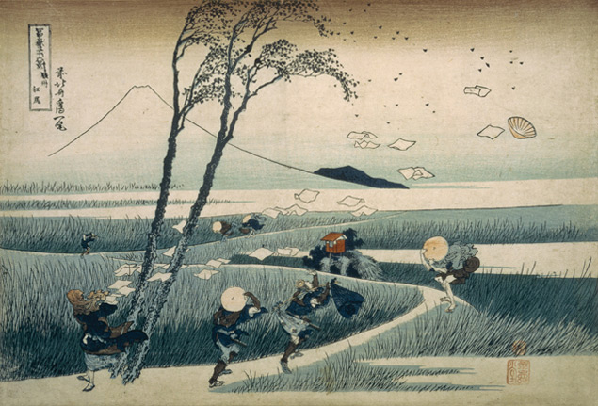Making connections through both FORM and MEANING.
You can compare anything, but it will only have convincing strength if there is solid ground for comparison, both formally and conceptually.
Comparisons do not need to be as directly referential as the Jeff Wall/Hokusai comparison on the left, but it is helpful to have some commonalities.

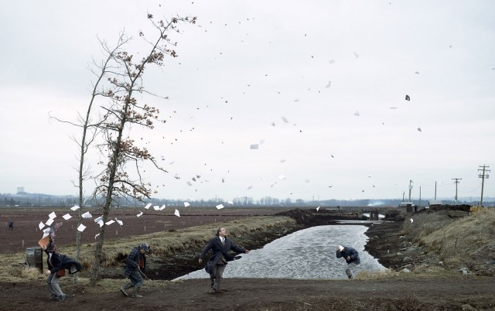
The page Comparing Images has examples of art works that lend themselves easily to comparisons.
The page Skills for CS has suggestions for how to build up to the Cs gradually through a series of guided comparisons.

Start with a piece of art that excites you

Use Primary Sources!
It’s great if students can see at least one of the works themselves!
An exhibition can be an excellent starting point for a CS, then each student can take it in different directions. As a matter of fact, why not use an exhibition visit as the starting point for the CS? If it is a big collection there will be plenty of room for individual choices of artworks.

How much help?
Teachers should provide guidance during the selection process BUT as this is a new activity for us, bear in mind:
“The teacher should discuss the choice of selected artworks, objects and artifacts with each student. It is important that the selected pieces are the student’s own choice.
Teachers should help students get started, read and give advice on first draft of the comparative study.
The teacher should provide oral or written advice on how the comparative study could be improved, but should not edit the draft.
The next version handed to the teacher must be the final version for submission.” from the VA guide

Teachers Resource
Download the pdf slideshow What is the Comparative Study?, 8 pages with more images and text! You can use this for yourself or to introduce the CS to your students.

Assessment

What are the assessed criteria for the CS?
A Analysis of formal qualities... ....................... 6 points
B Interpretation of function and purpose... ...... 6 points
C Evaluation of cultural significance................ 6 points
D Making comparisons and connections......... 6 points
E Presentation and subject specific language..6 Points
F (HL ONLY) Making connections to own art practice..12 points

Remember the CS is only 20% of the final mark, the other 80% is made up of the Process Portfolio and the Exhibition & Rationale.
For the most part all you will need to refer to is the basic breakdown into the 6 criteria in the blue box above, but for a complete breakdown of each criteria (what examiners will refer to) see this pdf Full CS Criteria-TH
It is only 20% of final mark so you do not want to give it too much of your precious studio hours! It can be done in an efficient and not too time consuming manner.

Getting Started
Need help structuring the CS? Go to the page on Structuring the CS for specific guidelines and useful tips.

Some helpful resources for finding artworks using reliable thematic search engines
http://www.metmuseum.org/collections/search-the-collections
http://www.art21.org/artists
http://www.google.com/culturalinstitute/collections?projectId=art-project
http://www.britishmuseum.org/research/collection_online/search.aspx
www.art2day.com
www.artsy.com

