http://www.thinkib.net/visualarts/page/16479/part-3-the-exhibition

Part 3, The Exhibition

- Overview
- New Visual Arts Curriculum
- The 3 Course Components
- Part 3, The Exhibition
In the new visual arts curriculum with first exams in 2016, Part 3 The Exhibition is 40% of final grade.
This component is internally assessed by the teacher and externally moderated by an examiner.
The final exhibition is the culmination of the students' IB Art experience. Students present a selection of their best work in the form of a curated final show, and defend and articulate their purpose and intention in a written rationale.

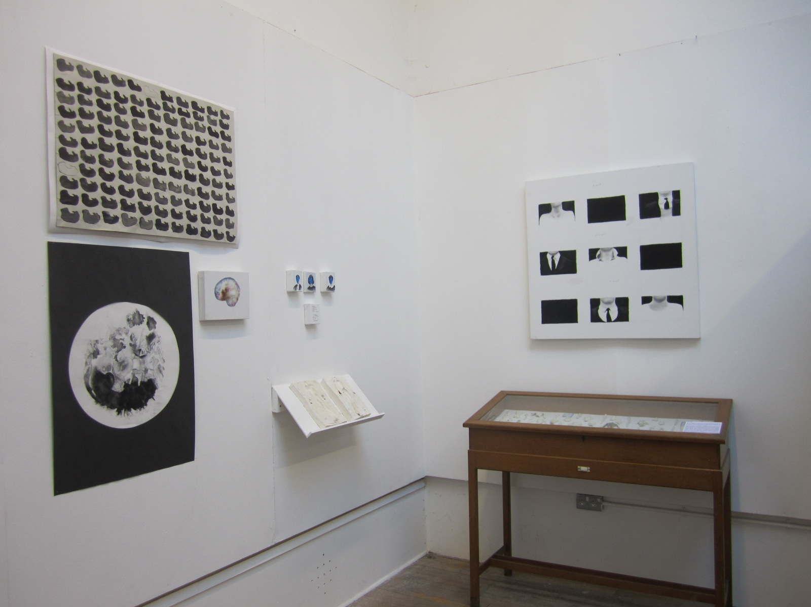

Selecting work for the Exhibition
Choose the strongest, most resolved artworks which show these qualities
• technical competence
• appropriate use of materials, techniques, processes
• work which communicates the stated intentions
• cohesiveness, unity among the works
• breadth and depth
• consideration for the overall experience of the viewer (through exhibition, display or presentation).
(note: students can present work for the exhibition in any medium, having met the requirements for the Process Portfolio of working in a range of art making forms)

What are examiners looking for in the exhibition?
technical accomplishment
conceptual strength of the work
resolution or communication of the stated intentions about the work

Other Requirements
Exhibition Text
For each piece included students write a brief exhibition text (a few lines) which states the title, medium, size and a brief outline of the original intentions.
Exhibition Overview Photos
Students may include two photographs of the overall exhibition. This is not for assessment purposes but to help the moderator (who won't see the actual exhibition) better understand the overall layout and experience.
(note: only include the exhibition artworks submitted for assessment in the photos)
Additional Supporting Photos (optional)
Students may choose to include up to two additional photographs of each submitted work. This is intended to provide a sense of scale when showing large works or for pieces that have more than one viewpoint, such as sculpture or installation. These extra photos are not necessary for most studio pieces.
The Curatorial Rationale
400 words max SL
700 words max HL
This is a written statement that accompanies the exhibition. The CR is not unlike the old candidate statement, but is longer, more in depth, and specifically addresses the body of work chosen for the exhibition. It explains the intentions of the student, considers the presentation the work using curatorial methodologies and the relationship with the viewer. Examples soon to follow! There will be a page dedicated to writing the CR, examples, etc.
The role of the Visual Arts Journal in the exhibition
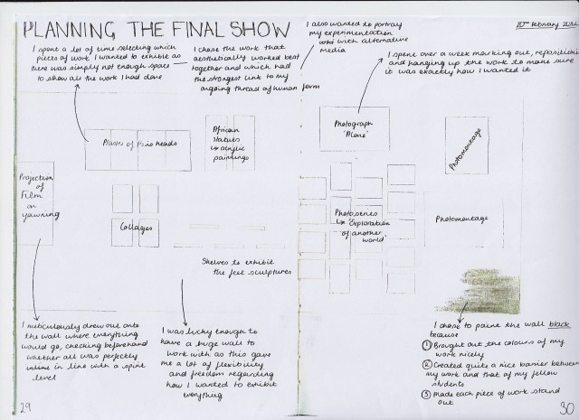Throughout the course students can use their visual arts journal to make notes of and reflect on their intentions while making their work, and they can be encouraged to document the developments of this thought process.
For the Curatorial Rationale students can make selections from and adapt passages from their journal.
The Visual Journal can also be used to plan the exhibition, consider the space, the display, the sequencing, the viewers role, and other curatorial issues.

For the requirements regarding the number of pieces in the exhibition go to Overview of Submission Requirements and for the full assessment criteria go to Exhibition Assessment Criteria

