http://www.thinkib.net/visualarts/page/16909/part-2-process-portfolio

Part 2, Process Portfolio

- Overview
- New Visual Arts Curriculum
- The 3 Course Components
- Part 2, Process Portfolio

The Journey
The Process Portfolio, or PP, is 40 % of the final mark and it is the testimony of the student's artistic journey during the course. It is not intended to be of polished, refined, or even resolved work; final work is presented for the Exhibition component of the course. The PP is a collection of carefully selected materials which document the students experimentation, exploration, manipulation and development of a variety of visual arts activities during the two-year course.
Download or view the presentation What is the Process Portfolio?

What will the PP contain?
Pages from the Visual Journal can be included in the PP as well as from other sketchbooks, notebooks, loose drawings, folios documenting the development of both resolved and unresolved works. The Visual Journal itself is not assessed but it is key in providing the bulk of raw material when compiling the screens for the PP.
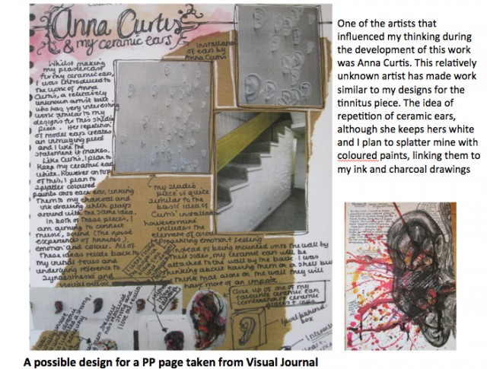

The PP doesn't have a set format, It is presented for assessment on screen but it can be compiled from various sketchbooks and other sources. Some students will create their PP entirely on screen, others will scan journal pages and most will do a combination of both. For more on this topic go to Process Portfolio Format

Art Making Forms
There is a requirement that encourages students to work across a range of media in the PP, however, this is not a particularly wide range and most teachers already include exposure to at least this many different media and techniques. The art making forms table breaks art forms into 3 main categories of 2D forms, 3D forms and lens based or electronic media.
SL students should work with at least two art-making forms from separate columns of the table.
HL students with at least three art-making forms, selected from a minimum of two columns of the table.
So for example if a HL student has worked with clay, printmaking and painting, she has already met the distribution requirements. Go to the page on Art Making Forms table for many more ideas to add on to this basic table.
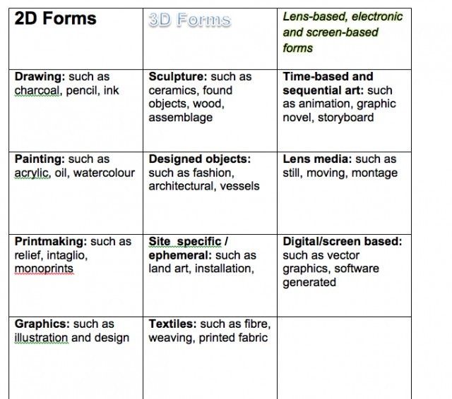

No double dipping
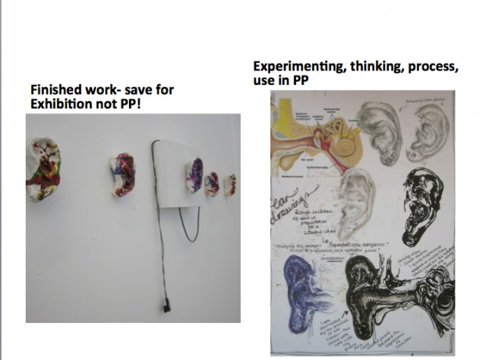
Work that appears in the PP may not be used for the Exhibition Presentation and vice versa.
This basically means that students can and should include developmental stages of work and various related experiments, including "failures" but the finished piece selected for the exhibitionshould not be included in the PP. It's merely a question of not repeating photographic documentation so that students cannot present the same work for both components.

Assessment

How much work?
Students submit a given number of screens rather than pages. There is no set specification as to how many words etc. A balance of visual and written content is desirable.
SL students submit 9–18 screens
HL students submit 13–25 screens
The assessment criteria for the PP include 5 criteria as shown in the table below. For more detailed discussion of each criteria go to Assessing the PP ( coming soon)
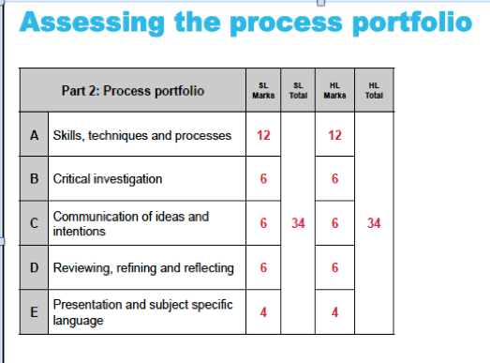

Truly a Process
This is good news for artists and teachers, the emphasis in the PP is on art making, hooray! The introduction of part 1, Comparative Study takes on the the function of the main academic exercise in critical analysis and leaves more room for open and unstructured visual experimentation in the PP.
A difference between the PP and the IWB is the significant increase in weight that is given toskills, techniques, and processes.
Criteria C and D also include an emphasis on visual forms of communication which is in line with the objectives of the curatorial rationale Error! Hyperlink reference not valid.

